Title Title Title Title Title Title Title Title Title Title Title Title Title Title
Name ^{a,} ∗
ª College, school, postal code, region

Abstract
Abstract content Abstract content Abstract content Abstract content Abstract content Abstract content Abstract content Abstract content Abstract content Abstract content Abstract content Abstract content Abstract content Abstract content Abstract content Abstract content Abstract content Abstract content Abstract content Abstract content Abstract content Abstract content Abstract content Abstract content Abstract content Abstract content Abstract content Abstract content Abstract content Abstract content Abstract content Abstract content Abstract content Abstract content Abstract content Abstract content Abstract content Abstract content Abstract content Abstract content Abstract content Abstract content Abstract content Abstract content Abstract content Abstract content Abstract content Abstract content Abstract content Abstract content
Keywords: Keywords; Keywords; Keywords; Keywords; Keywords

1 Introduction
text content text content text content text content text content text content text content text content text content text content text content text content text content text content text content text content text content text content text content text content text content text content text content text content text content text content text content text content text content text content text content text content text content text content text content text content text content text content text content text content
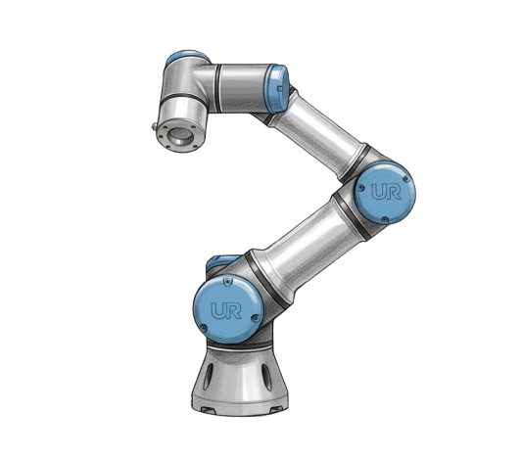
Figure 1. XXXXXXXXX.
2. Materials and Methods
$\begin{aligned}x_{norm}=\frac{x-μ}{σ+ϵ}\#\left(1\right)\end{aligned}$3. Results

4. Conclusion

Funding
This work was supported without any funding.
Data Availability
If necessary, it can be provided. If necessary, it can be provided.
Competing Interests
The authors declare no competing interests.

References
Ali, M. M. (2025). Digital Twin Synchronization and Control of Robot Arm-Based Manufacturing via Reinforcement Learning and Unity University of Louisiana at Lafayette].
Faccio, M., Granata, I., Menini, A., Milanese, M., Rossato, C., Bottin, M., Minto, R., Pluchino, P., Gamberini, L., & Boschetti, G. (2023). Human factors in cobot era: a review of modern production systems features. Journal of Intelligent Manufacturing, 34(1), 85–106.

∗ Corresponding author. E-mail: XXXX

